xpedx.com Next Generation
Technical Design Specification – <Item Master Load>

Authors: | Sterling Commerce
Version: | 0.1
Date Created: | 3/30/2010
Last Updated:

Document Revision History
Revision | Date | Description | Author
0.1 | 03/08/2010 | Draft | Sterling Commerce

Document Approval History
Name | Signature | Date | Version Approved/Comments

Reference Documents
Document Name | Description | Owner | Location
SCI_Xpedx Solution Definition Document v1.0 | Solution Definition document | Sterling Commerce

Table of Contents
1. Introduction 4
1.1. Purpose 4
1.2 Nomenclature 4
1.3 Performance Considerations 4
2. Technical Components 4
2.2 Components Overview 4
2.3 Component Design 4
2.3.1 Design for xpedxAsynchLoadItemMaster 4
2.3.2 UI Design 5
2.3.3 UI Validations 5
2.3.4 Input Document 5
2.3.5 Output Document 5
2.3.6 Configuration 5
2.3.1.1. <Insert Sub-Component Name> 6
3. Database Extensions 7
4. Exception and Error Handling 7
5. Security Aspects 7
5.1 Ownership 7
5.2 Encryption 7
5.3 Audit Trail 7
5.4 Other Security Aspects 7
6. Dependencies 7
7. Unit Test Cases 8
7.1 <Insert Component Name> 8

1. Introduction

Purpose
- XReference Section 1.1 – Document Purpose in Functional Design Document
2. UI ref to HLD, if HLD has the UI details.

1.2 Nomenclature
<Glossary of terms - list only new terms applicable to this design>

Term | Description
CSR | Customer Service Representative
P&A | Price and Availability

1.3 Performance Considerations
List of all the factors that impact performance

2. Technical Components

2.1 Components Overview
The xpedx Content Director generates a delimited flat file containing item information. This flat file contains new items which have been added to the xpedx catalog as well as existing items which have changed. This component reads the flat file and uploads the information into the Sterling system creating new items or updating existing items present in the Sterling catalog.

2.2 Component Design

- xpedxAsynchLoadItemMaster

2.2.1 Design for xpedxAsynchLoadItemMaster

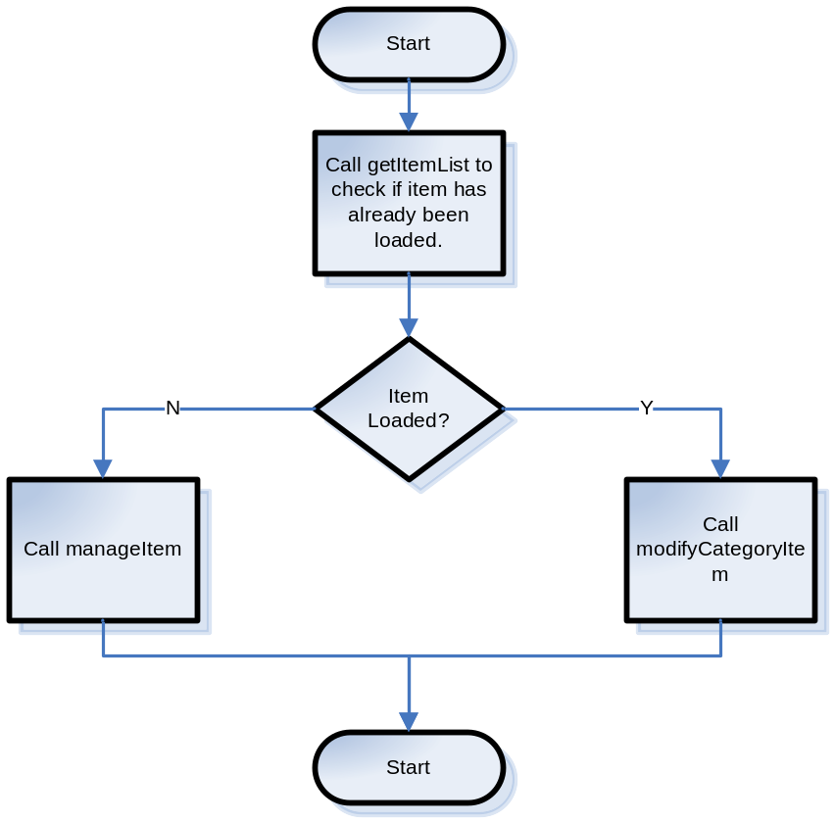
< Elaborate the component design here. Provide all the details that will be required to implement this component. This will be the bible for the developer for smoothly implementing this component. Any UML diagrams (i.e., Class diagrams, Sequence Diagrams etc.) can be included here>

2.3.2 UI Design
<This section is applicable to UI components. Provide a UI mockup and elaborate the design for UI>N/A

2.3.3 UI Validations
<This section is applicable to UI components. Provide the various validations that need to be applied for each field/control on the UI mock-up>N/A

2.3.4 Input Document
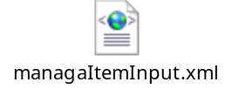

2.3.5 Output Document
<Provide a sample output XML with valid values for each attribute>N/A

2.3.6 Configuration
Create service xpedxAsynchLoadItemMaster

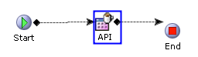

Properties: API
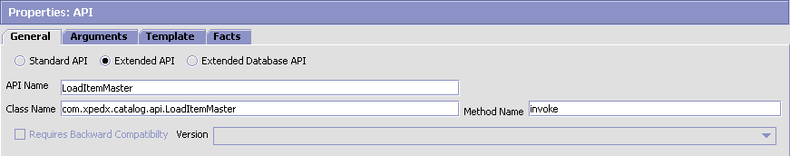

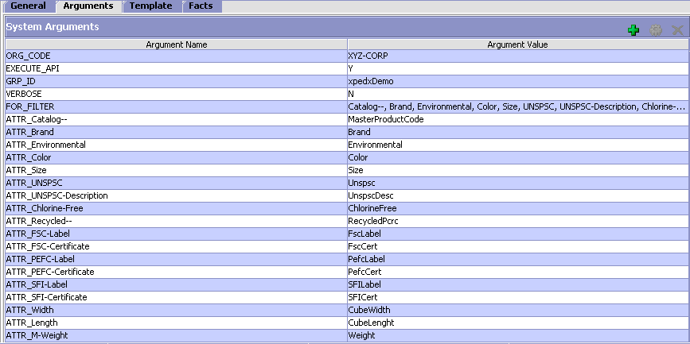

2.3.1.1. <Insert Sub-Component Name>
<Elaborate input and output of each sub-component if applicable>N/A

- Input Document

- Output Document

3. Database Extensions
<Provide the database extensions required for the component in the format provided below. The data types need to be clearly specified. Always Out-of-the-box data types should be reused. If a data type for the given combination doesn’t exist, a new data type name should be specified>

<Database Extension Template>
Table Name
Overview
Extensions/Custom/Hang-off
Primary Keys
Index on
Attribute Name | Column Name | Data Type/Size | OOB Data Type Name | Default Value | Description
ExtnOntology | EXTN_ONTOLOGY |  | CatalogId | ‘ ‘ | Ontology associated with Item

4. Exception and Error Handling
This component will throw an InvalidCategory exception if the category to which the item is to be attached has not been created.
<Provide the list of exceptions (business and system exceptions) the component can throw>

5. Security Aspects
<Provide details on the security aspects of this implementation. Where would these security components reside, what will be encryption that will be used and any audit trails required>N/A

5.1 Ownership
5.2 Encryption
5.3 Audit Trail
5.4 Other Security Aspects

6. Dependencies
<For issues that are dependent on customer: Record all dependencies made for this design including business requirement, performance and technical factors, etc. in JIRA and list the JIRA tickets numbers here

JIRA no | desc | To be validated by  (Team/Person) | Status | Implications if incorrect

<For issues those aren’t dependent on customer: Record all dependencies made for this design including business requirement,performance and technical factors, etc. here

Include only those that are not already documented in SDD If there are changes in SDD, reference the specific dependency and state the revised assumption. New assumption should be approved prior to design review> XReference Section 2.8 – Assumptions in Functional Design Document.

No. | Assumption | To be validated by  (Team/Person) | Status | Implications if incorrect

7. Unit Test Cases
<Elaborate unit test cases for all the components. Every unit test case should include description, pre-requisites, expected results, etc. The below section should repeat for each component>

7.1 <Insert Component Name>

Test No. | Test Description | Execution Instructions | Expected Result

